**Excel Assignment - 6**

1. **What are the various elements of the Excel interface? Describe how they're used.**

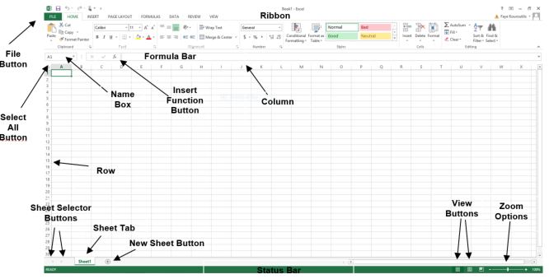

1. **Write down the various applications of Excel in the industry.**
2. Data Entry and Storage. At its most basic level, Excel is an excellent tool for both data entry and storage. ...
3. Collection and Verification of Business Data. ...
4. Administrative and Managerial Duties. ...
5. Accounting and Budgeting. ...
6. Data Analysis. ...
7. Reporting + Visualizations. ...
8. Forecasting.

**3. On the ribbon, make a new tab. Add some different groups, insert commands in the groups and name them according to their commands added. Copy and paste the screenshot of the steps you followed.**

**Right click on Ribbon > Customize the Ribbon > review Tab > Add New Tab**

4. Make a list of different shortcut keys that are only connected to formatting with their functions.

* **CONTROL + B**: Applies bold font formatting to headers
* **ALT + H + B + A**: Applies borders to the cells
* **ALT + H + B + T**: Gives an outline border to the dataset
* **ALT + H + O + W**: [Autofits](https://trumpexcel.com/autofit-excel/) column widths
* **CONTROL + 1:** Opens Format Cells dialog box

**5. What distinguishes Excel from other analytical tools**

One of the reasons Excel is so popular is because it is jam-packed with features and functions that can be used to [clean](https://careerfoundry.com/en/blog/data-analytics/what-is-data-cleaning/), aggregate, pivot, and graph data. In this article, we’ll go over the 10 features and functions for using data analysis in Excel I think every analyst needs to know:

1. [Pivot tables and pivot charts](https://careerfoundry.com/en/blog/data-analytics/data-analysis-in-excel/#pivot-table-pivot-chart)
2. [Conditional formatting](https://careerfoundry.com/en/blog/data-analytics/data-analysis-in-excel/#conditional-formatting)
3. [Remove duplicates](https://careerfoundry.com/en/blog/data-analytics/data-analysis-in-excel/#remove-duplicates)
4. [XLOOKUP](https://careerfoundry.com/en/blog/data-analytics/data-analysis-in-excel/#xlookup)
5. [IFERROR](https://careerfoundry.com/en/blog/data-analytics/data-analysis-in-excel/#iferror)
6. [MATCH](https://careerfoundry.com/en/blog/data-analytics/data-analysis-in-excel/#match)
7. [COUNTBLANK](https://careerfoundry.com/en/blog/data-analytics/data-analysis-in-excel/#countblank)
8. [DAYS and NETWORKDAYS](https://careerfoundry.com/en/blog/data-analytics/data-analysis-in-excel/#days-networkdays)
9. [RANK](https://careerfoundry.com/en/blog/data-analytics/data-analysis-in-excel/#rank)
10. [SUMPRODUCT](https://careerfoundry.com/en/blog/data-analytics/data-analysis-in-excel/#sumproduct)

6. Create a table and add a custom header and footer to your table

Create a table and add a custom header and footer to your table

Go to Insert > Header or Footer. Choose from a list of standard headers or footers, go to the list of Header or Footer options, and select the header or footer that you want. Or, create your own header or footer by selecting Edit Header or Edit Footer. When you're done, select Close Header and Footer or press Esc.